Solar Battery Monitoring Circuit User Manual

# Connections and Wiring

* We use 1 mm² or preferably 1.5 mm² wire for the screw terminal connections.
* You need to make sure to use a wire ferrule (embouts de fil) which needs to be tightly gripped to the wire strands on the terminal side in order to maintain wire pressure and avoid excessive contact resistance. Do this for all screw terminal connections (see Figure ‎1‑1).
* We use a very large diameter wire between the batteries and the current resistor to avoid unnecessary voltage drops.
* The screw terminal connections are indicated by the color of the squares near them. The right screw (with the white square near it) should go to the positive terminal of the power resistor. The left screw (green square) should go to the 24V battery’s positive terminal. The middle screw is for the 0V (Ground) which is taken as the negative terminal of the first battery. (See Figure ‎1‑2 and Figure ‎1‑3). The color squares are circled in red in Figure ‎1‑2.
* Tighten the screws as much as possible to decrease contact resistance.
* Connect the 0V and 12V (white) screws to their respective wires and check if the buck converter (the blue rectangle on the right of Figure ‎1‑2) turns on.
* Proceed to connect the power resistor and then the 24V terminal before turning the red switch on (place it in the (I)position).

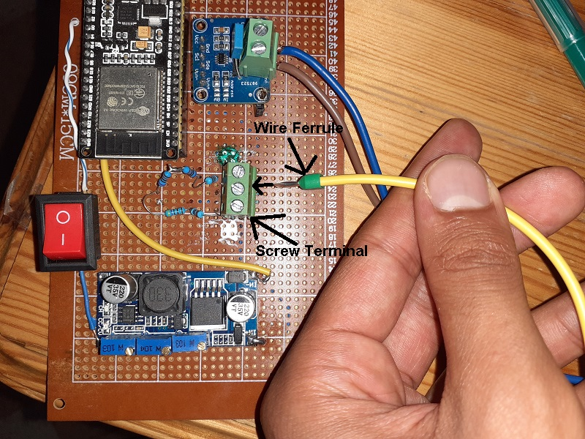

Figure ‎1‑1

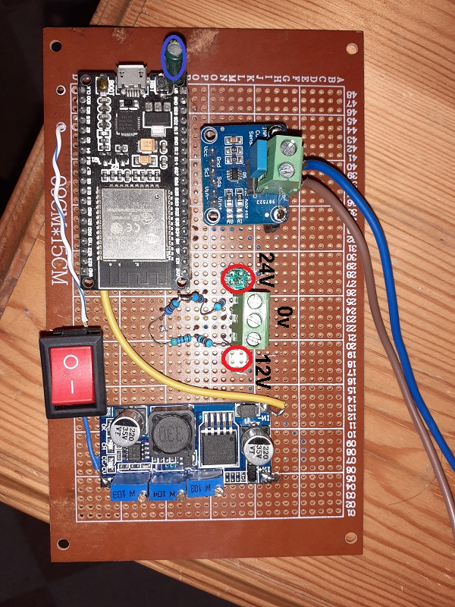

Figure ‎1‑2

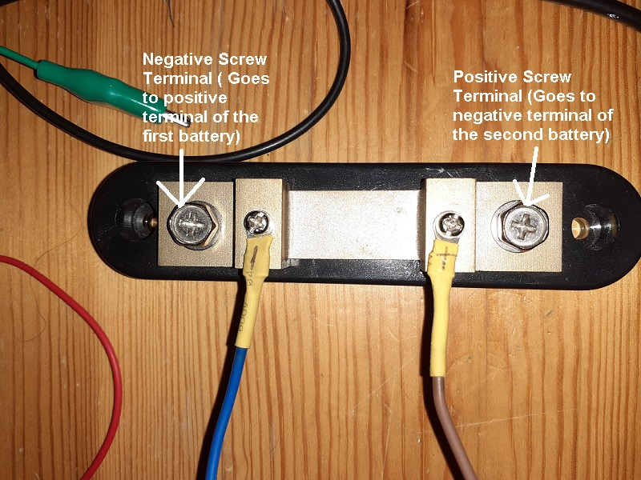

Figure ‎1‑3

# General Guidelines

* There needs to be internet connection when you first turn the system on.
* If the microcontroller led is blinking every two seconds and is not sending data to the cloud, reset the microcontroller and make sure your internet connection is stable.
* Keep the capacitor encircled in violet in Figure ‎1‑2 always in an upright position.